Comparative Study of Countries By Khurshid Khan

**Step 1:** Open **Tableau 10.x**

**Step 2:** On the home page, under **Connect,** under **to a file,** click **Excel.**

**Step 3:** Browse and connect to the **Global Financial Development Database - Jul2018** Excel file.

**Step 4:** Drag and drop **Data July 2018** tables to the canvas area.

**Step 5:** Click on Add button to connect **Insurance Sample Dataset** Excel file.

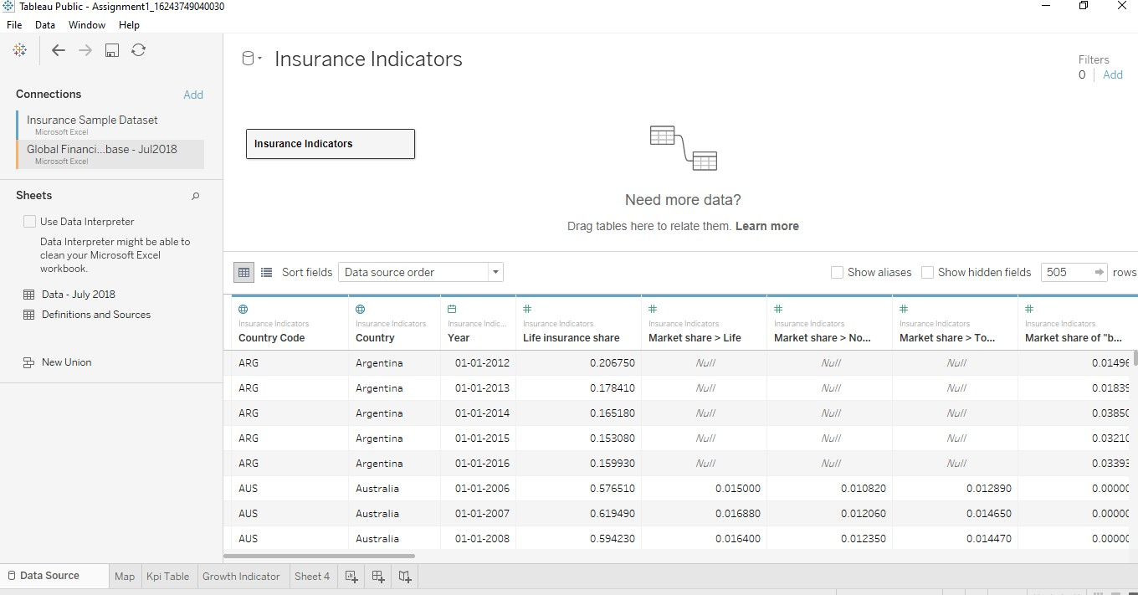

**Step 6:** Go to Sheet one and rename it as MAP.

**STEP 7:** To Create a **MAP**, drag **Country** from **Insurance Sample Dataset** and put on Detail Mark card and then go to automatic and click map. Then drag Income from **Global Financial Development Database** to filer and select all and click on show filter. Drag **Income** to Colour Mark Card and **Country Code** to text Mark card.

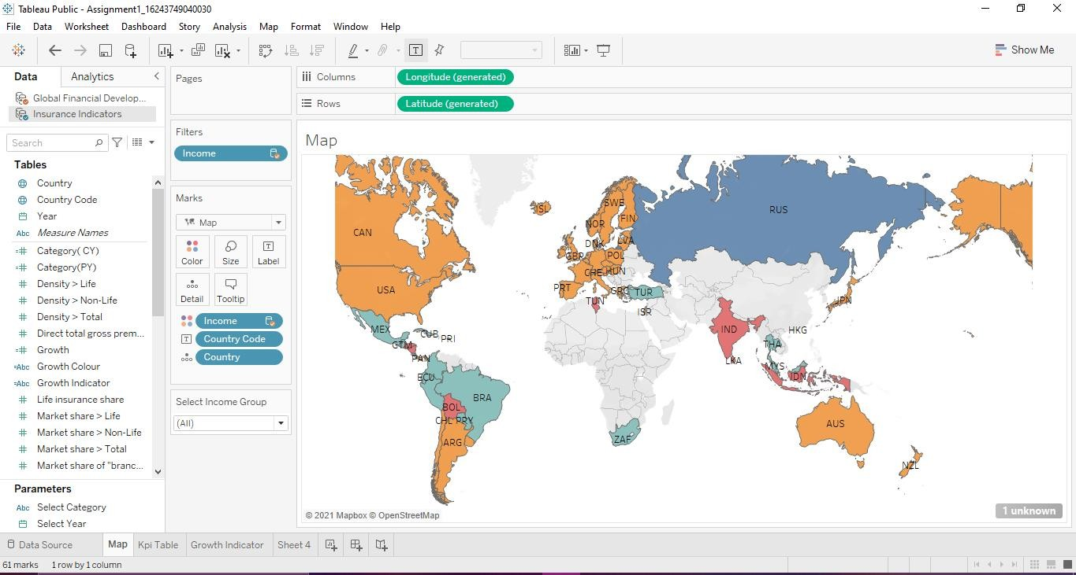

**Step 8:** Create 2 Parameters , One for **Select Year** and Another **Select Category.**

**Step 9:** To create Parameter go to Down key below Filter button in Data panel , And click on Create Parameter. For Year parameter click on Date datatype and for Select Category Click on String Data type.

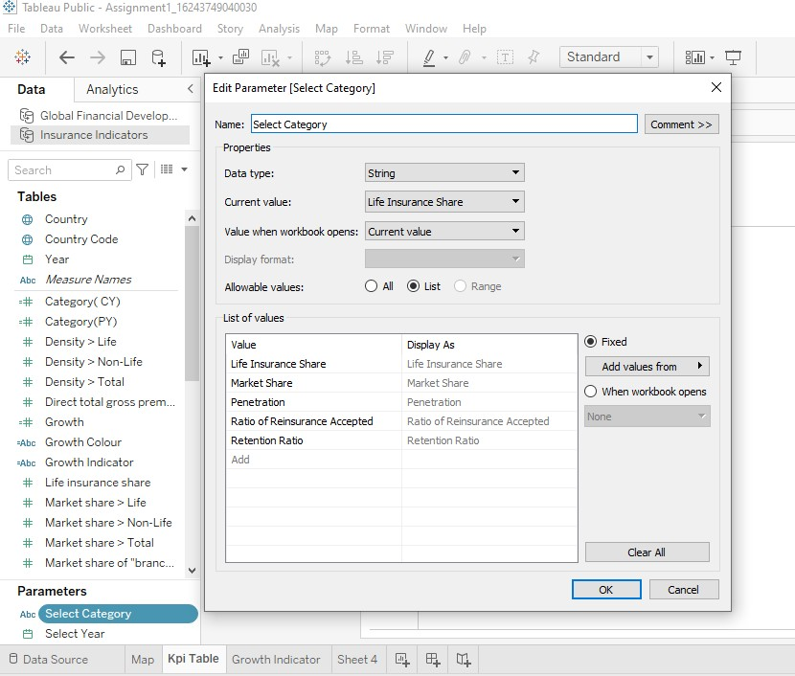**Step 10:** Create **Calculated Field:** To Select 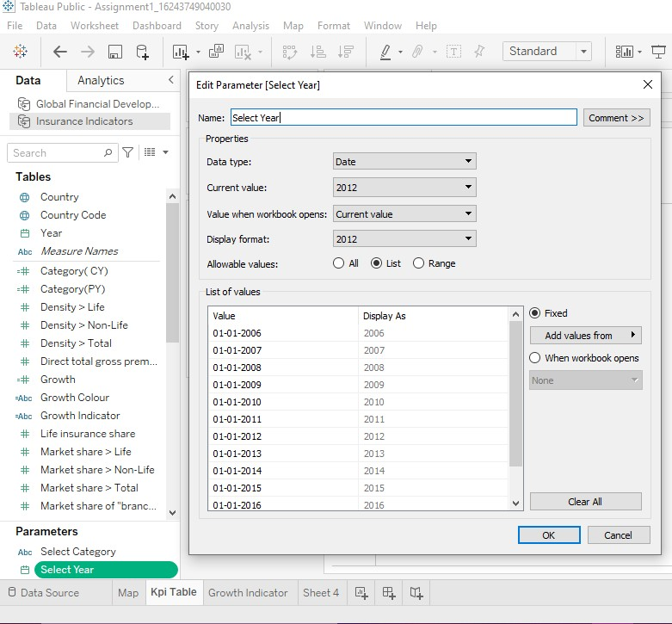 Category, Categorial CY(Current year) and Categorial PY(Previous Year),Growth %.

Click on Analysis Pane , and then Calculated Field and do calculations for the following.

Select Category is for : to Select Category Parameter Categorial CY: Selected Period Value

Categorial PY : Comparison Period Value Growth : For Growth %

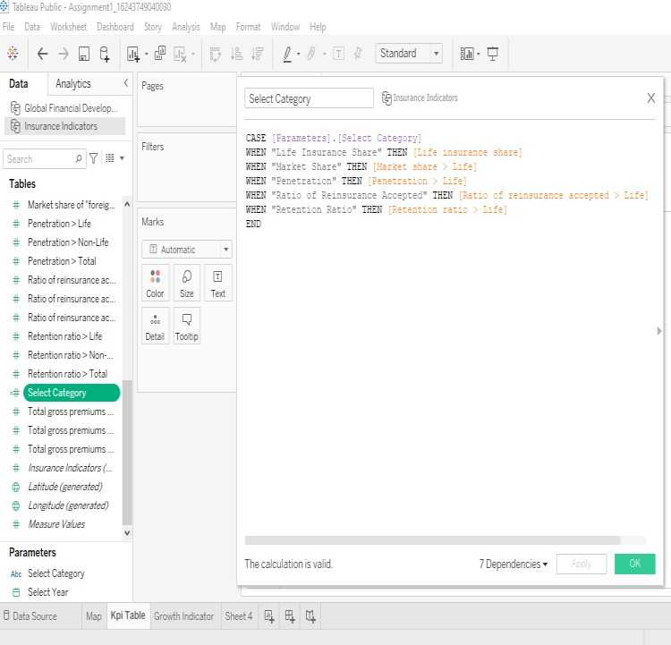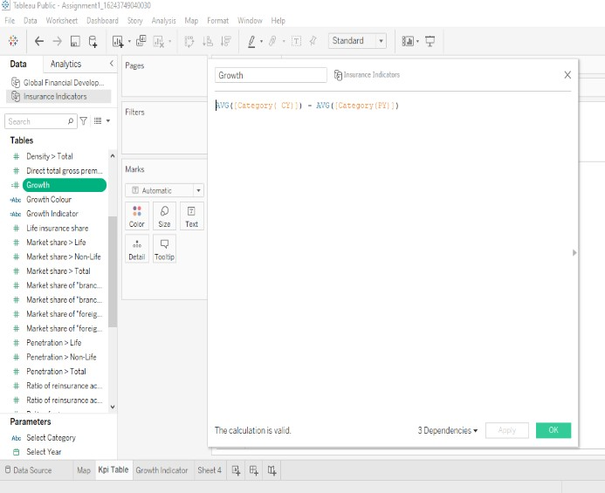

**Step 11:** Create a **KPI Calculator**: Go to new sheet and rename it KPI table and click on Sheet title and insert Select Category

Click on Parameters and Show Parameter.

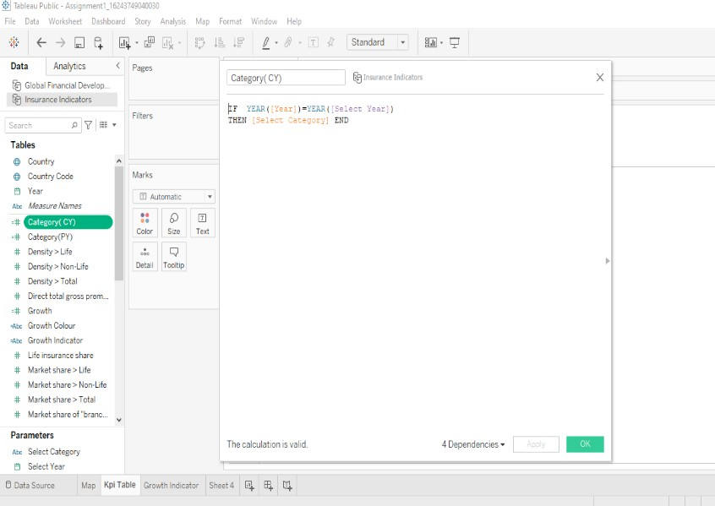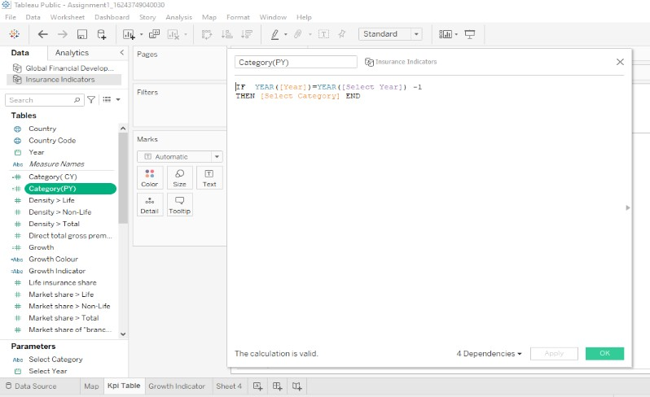

Drag Measure Names to Row and filter it to Categorical CY , Categorial PY , Growth. And Measure Values to Text Mark card

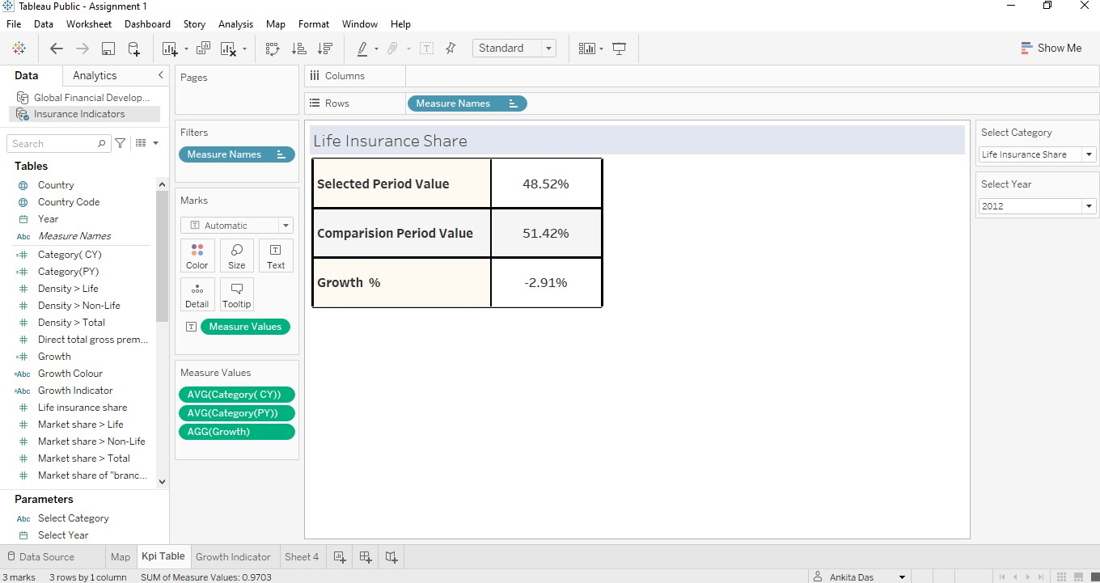

**Step 12:** To create a growth indicator:

Create 2 Calculated Field: Growth Colour and Growth Indicator:

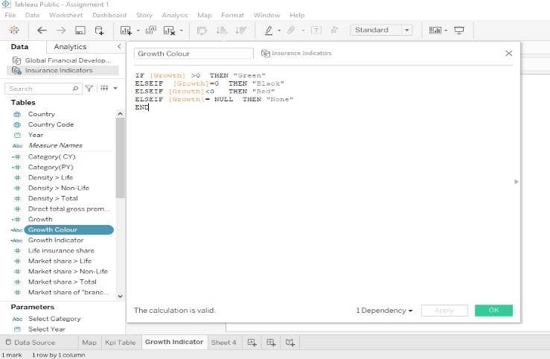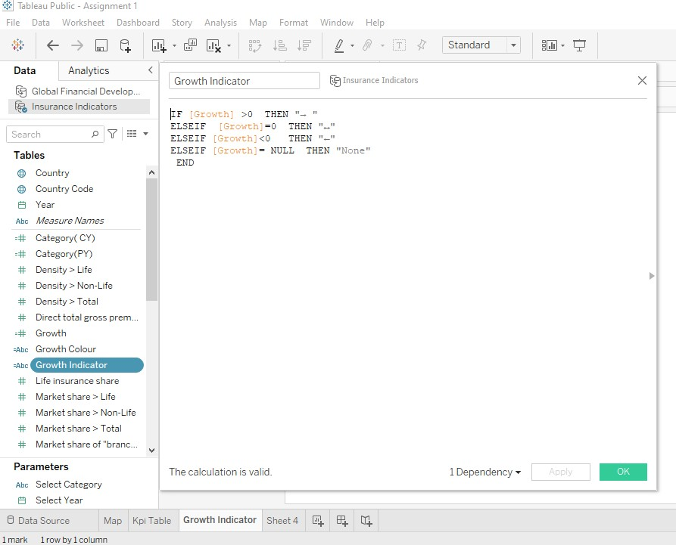

**Step 13:** Growth Indicator Visualization : Go to New Sheet and rename it Growth Indicator

Click on Parameters and Show Parameter.

Drag Growth Colour to Colour and Growth Indicator To text.

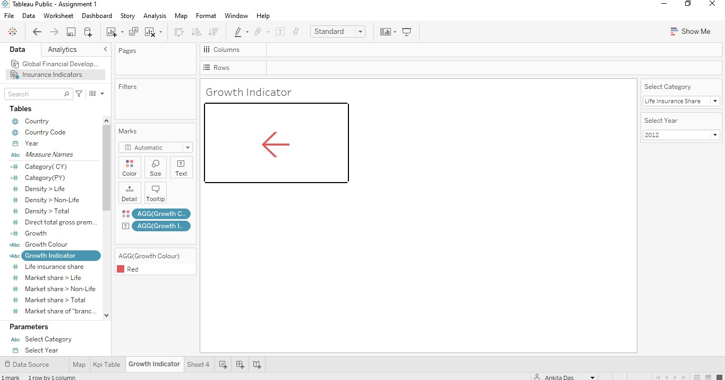

**Step 12:** To Create Trend Chart: Go to New sheet and rename it Trend Chart. Click on Parameters and Show Parameter.

Drag Year to Columns and Select Category Measure to Rows.

Year to Pages [To make a Motion Chart] and click on Show history and Trails.

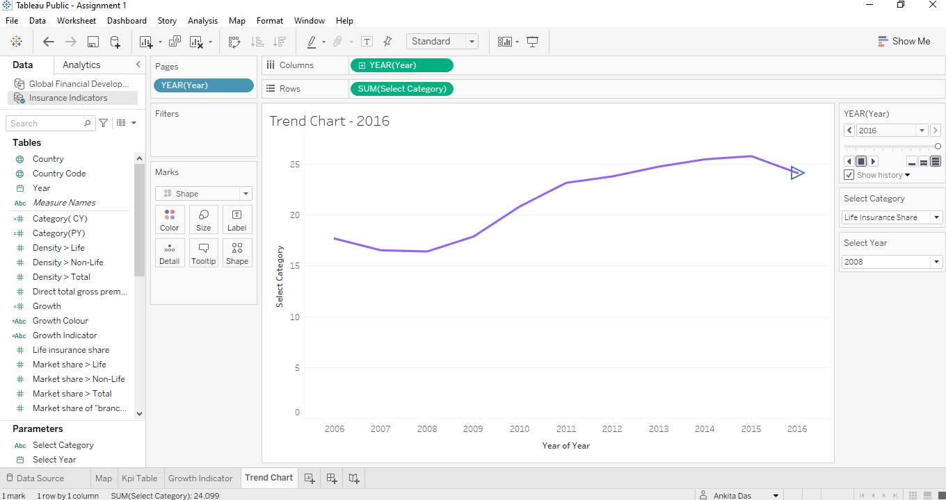

**Step 14:** Create a Dashboard: Click on Dashboard button . Go to Size and click Automatic.

Go to Objects and click on Horizontal, Then Vertical , and then Horizontal, Drag Map to sheet , From Objects drag web Page to sheet.

Then Go to Dashboard , Click Action -> add action -> go to URL -> edit action-> Source sheet -> Map and Run action -> Select

And add URL in URL bar.

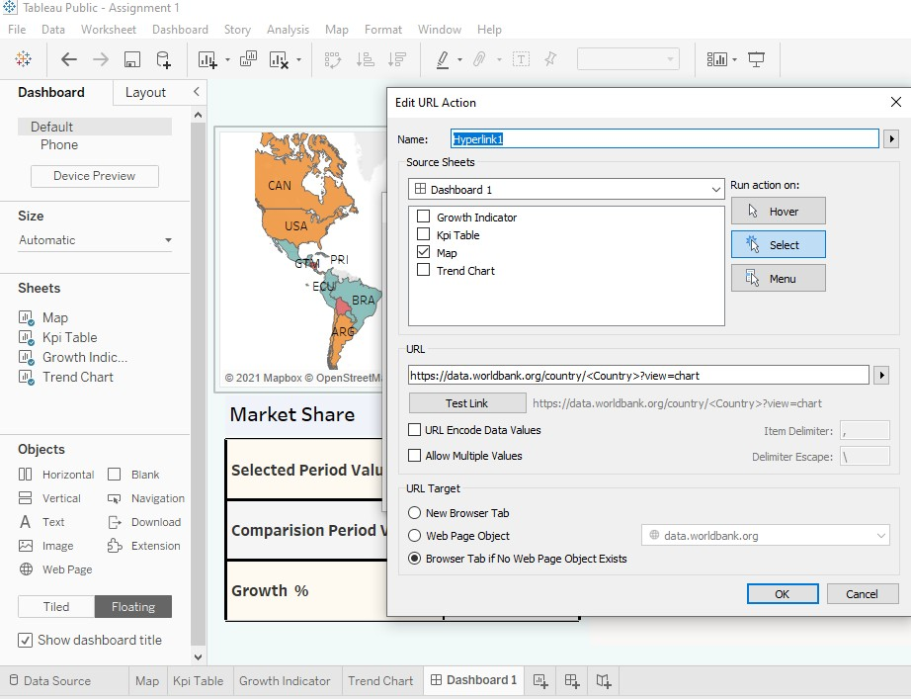

Go to Object , the drag Horizontal Tab again.

Click on Floating -> add KPI sheet, Growth Indicator sheet and Trend Chart sheet and rearrange it.

Then click on Select Income Filter -> More options -> Apply to Worksheets -> Selected worksheet -> click on All on Dashboard.

Then click on Dashboard -> click on actions -> add action -> filter-> edit filter -> source sheet -> KPI table

Target sheet-> All except KPI table Run on action -> Click on Select.

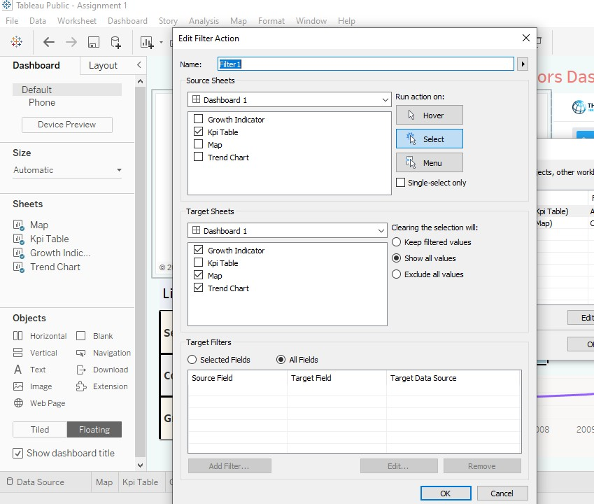

**Step 15:** Dashboard ready to slideshow.

